

ISO9001:2015 Quality System Certification



Committed To Creating The Best
Intelligent Control Terminal
Contents

File information 3
Change records 3
Change review 3
1. Contact Us 4
2. Company Environment 4
3. Product Description 5
3.1 Product Models 5
3.2 Products Features 7
3.3 Products Size 8
3.4 Products Parameters 9
4. Hardware Introduction 11
4.1 Definition of terminal pin 11
5. Reliability Test 13
5.1 ESD Test 14
5.2 High low Temperature Aging Test 15
5.3 Electrical Fast Transient test 16
5.4 Lightning Surge Test 18
6. Software Download 20
7. Description PC Configuration Software 20
7.1 Develop software 20
7.2 Protocol Configuration 24
8. Development Of The Document 25
File information
Writer |  | The date of writing
Reviewer |  | The date of the review
Approver |  | The date of approval

Change records
date | author | version | Change instructions

Change review
date | Reviewer | opinion

- Contact Us

Shenzhen Kinseal Intelligent Control Technology Co., LTD
Floor 3, Yaoji Building 1, Xinhetongfufu Industrial Zone,
Fuhai Street, Bao 'an District, Shenzhen
Company Web Site：www.kinseal.com
Business Of Selling：086-136 4144 2131
Technical Support：086-186 8246 9902

- Company Environment


- Product Description
  - Product Models

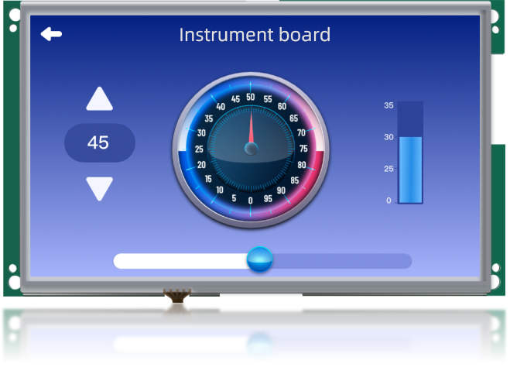
型号 | 规格说明
AMZ101P24W01RES | AMZ series, 10.1 inch,Serial screen,10-30V,serial port 1: RS232, serial 128Mbyte SPI Nand Flash, Resistive touch screen
AMZ101P24W01RDS | AMZ series, 10.1 inch,Serial screen,10-30V,serial port 1: RS485, serial 128Mbyte SPI Nand Flash, Resistive touch screen
AMZ101P24W01REE | AMZ series, 10.1 inch,Serial screen,10-30V,serial port 1: RS232, serial port 2: RS232,128Mbyte SPI Nand Flash, Resistive touch screen
AMZ101P24W01RED | AMZ series, 10.1 inch,Serial screen,10-30V,serial port 1: RS485 serial port 2: RS485,128Mbyte SPI Nand Flash, No touch
Model Definitions
Figure Shows：

AMZ 101 P24 W01 R E S

E indicates that serial port 2 is RS232，D is RS485，S is Not supported

E indicates that serial port 1 is 232，D indicates that serial port 1 is 485

R means resistance touch, C means capacitive touch, N means no touch

Indicates the flash type，01：SPI NAND Flash；02：SPI NOR Flash

Represents a 10.1-inch bare screen without a housing

Indicates the product model size 10.1 inches

Represents AMZ series HMI

3.2 Products Features

Power Voltage | DC10-30V
Backlight Adjustment | Support
Touch | 4-wire resistive touch screen，Capacitive touch screen support
LCD resolution | 1024X600
USB1 | Micro USB
USB2 | TYPE-A
LCD | TN TFT LCD，250cd/m2
COM1 communication | RS232/RS485communication(2 choose 1)
✓COM2 communication | RS232/RS485通讯（2 choose 1）
Storage | 128Mbyte SPI NAND FLASH
Power Protection | To prevent the reverse，Distinguish the positive and negative poles of power supply
RTC | Support
Save power failure data | Support
Download | SD card，USB download，U disk

3.3 Products Size

Display Size | Product Model | Overall Dimension | Display Visual Area | Panel Cutout | Overall Thickness
10.1 in. | AMZ101P24 | 257.7*148.3mm | 222.7*125.3mm | 247.5*120.4mm | 22mm

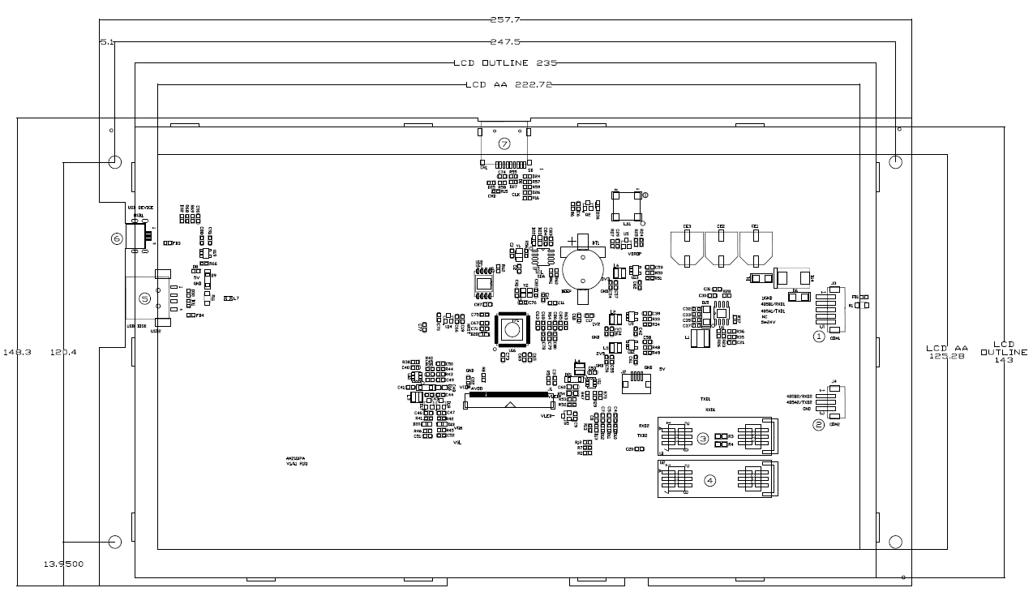

3.4 Products Parameters

Product Specification
Hardware Performance | Module | AMZ101P24
Hardware Performance | Display Size | 10.1" TFT LCD
Hardware Performance | Resolution | 1024X600
Hardware Performance | Colors | 260000
Hardware Performance | Brightness | 250 cd/m²
Hardware Performance | Backlight | LED
Hardware Performance | LED life | 20000 hours
Hardware Performance | Touch screen | 4-wire resistive touch screen touch screen（Surface hardness 4H）Capacitive touch is supported
Hardware Performance | CPU | 32-bit 600MHz ARM9 built-in 32MB DDR2 memory
Hardware Performance | Memory | 128Mbyte SPI Nand Flash
Hardware Performance | RTC | Real-time clock built-in
Hardware Performance | Ethernet | Unsupported
Hardware Performance | Save power failure data | Support
Hardware Performance | USB | A USB2.0 Device port，A USB2.0 HOST port
Hardware Performance | Program download Mode | USB，U disk，SD card
Hardware Performance | U disk | Support
Hardware Performance | Communication port | COM1：RS232,RS485(2 choose 1)  COM2：RS232,RS485(2 choose 1)
Electrical Specifications | Maximum power consumption | 3.5W
Electrical Specifications | The rated voltage | DC 10-30V
Electrical Specifications | Power protection | +/-2KV lightning surge protection capability
Electrical Specifications | The allowed loss of power | <5ms
Electrical Specifications | CE&ROHS | Comply with EN61000-6-2:2005, EN61000-6-4:2007 standards;Lightning surge +/ -2kV, EFT: +/ -4kV;Electrostatic contact discharge +/-8KV;Electrostatic air discharge +/-10KV.
Environmental Specifications | Operating temperature | -20℃~50℃
Environmental Specifications | Storage temperature | -40℃~70℃
Environmental Specifications | Environmental humidity | 10~90%RH(non-condensing)
Environmental Specifications | Vibration | 10-25Hz (X, Y, Z direction, 2g/30 min)
Environmental Specifications | Cooling way | Natural air cooling
The Other Parameters | Protection grade | The front panel conforms to IP65 (with flat plate cabinet installation), and the rear panel conforms to IP20
The Other Parameters | Display Active Area | 222.7*125.3mm
The Other Parameters | Panel Cutout | 247.5*120.4mm
The Other Parameters | Overall dimensions | 257.7*148.3mm
The Other Parameters | The weight | 280g

- Hardware Introduction
  - Definition of terminal pin

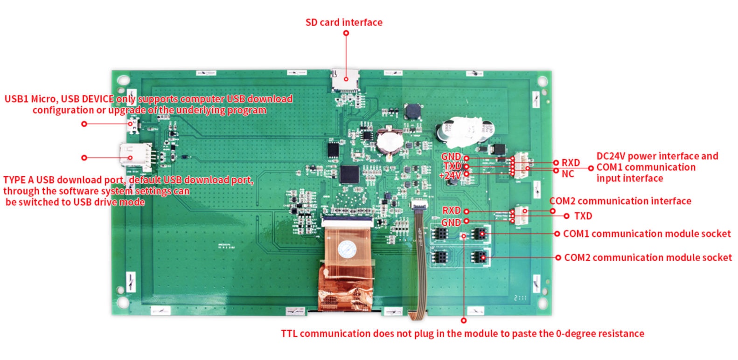
Port Definitions
Device Position Number | Descriptions
 | DC24V power interface and COM1 communication input interface
 | COM2 communication interface
 | COM1 RS485 communication module interface, plug 485 module
 | COM1 RS232 communication module interface, plug 232 module
 | R3, R4 resistance, when COM1 selects TTL, a 0 euro resistor is required
 | COM2 RS485 or RS232 communication module interface
 | TYPE A USB download port, default USB download port, through the software system settings can be switched to USB drive mode
 | Micro USB
 | SD card interface

COM1The output interface——①
Pin | Definition | Descriptions
1 | GND | Negative power input
2 | RXD | RS232_RX,RS485B,TTL_TXD | 3 choose 1
3 | TXD | RS232_TX,RS485A,TTL_TXD | 3 choose 1
4 | blank | blank
5 | +24V | Positive input of power supply

COM2The output interface——②
Pin | Definition | Descriptions
1 | RXD | RS232_RX,RS485B | 2 choose 1
2 | TXD | RS232_TX,RS485A | 2 choose 1
3 | GND | GND

COM1Communication Mode-③④⑤status selection
COM1 communication methods / device location | ③④---COM1 module | ⑤---resistance R3 R4
RS232 | Plug in the RS232 module | blank
RS485 | Plug in the RS485 module | blank
TTL | blank | Attach a 0-degree resistance

COM2Communication Mode-⑥status selection
COM2 communication methods / device location | ⑥---com2 module
RS232 | Plug in the RS232 module
RS485 | Plug in the RS485 module
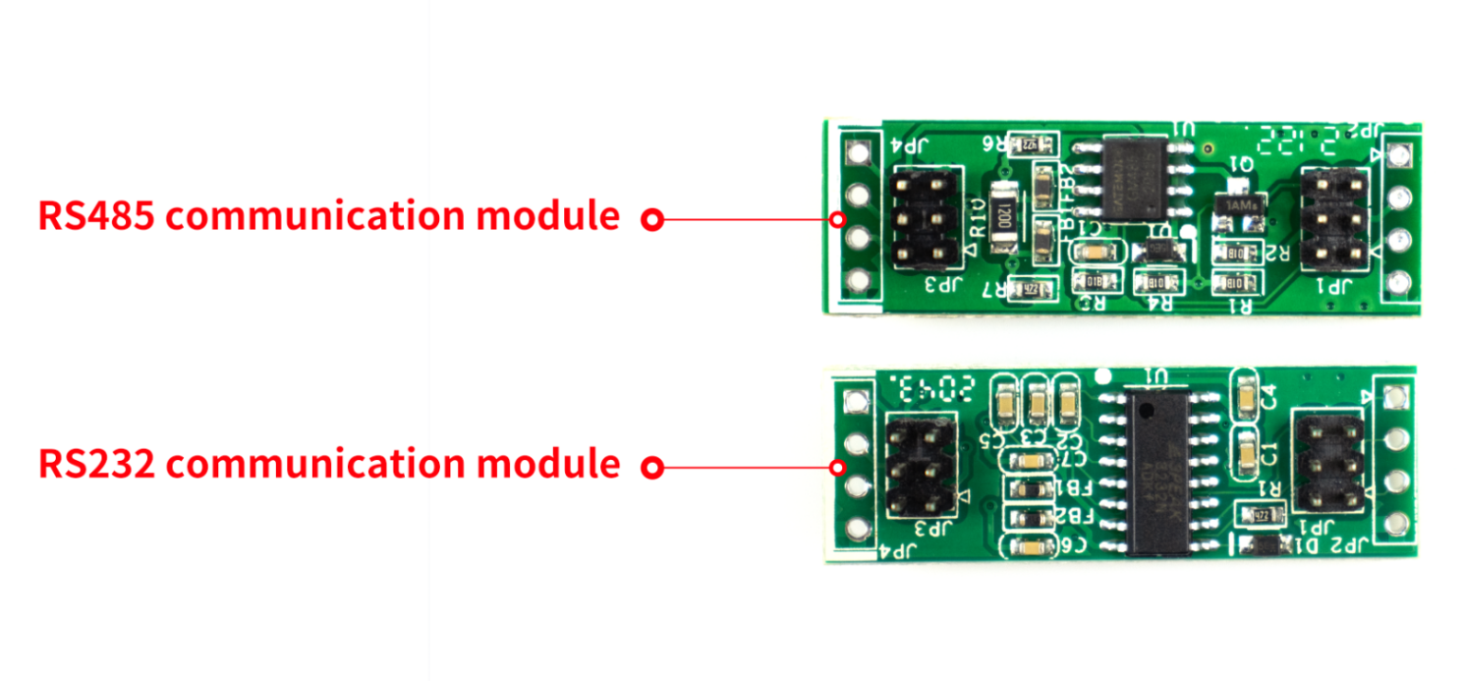

- Reliability Test
All products of company have carried out a series of reliability tests before mass production , including ESD test, high and low temperature aging test, EFT and so on, to ensure the quality of products

5.1 ESD Test
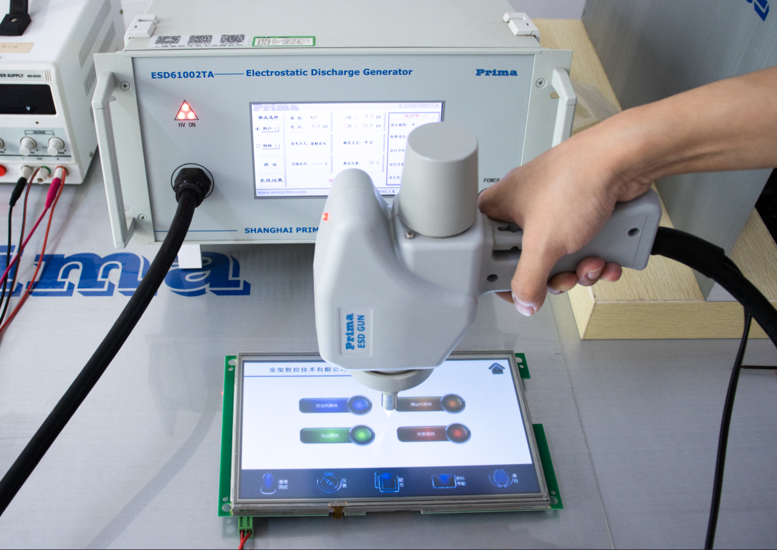
Execution standard：IEC 61000-4-2
Test process: Lay the product flat on the test table, and conduct contact and air discharge in turn around the touch screen iron buckle and the display area, as showing above. Check the screen is weather reset and displayed abnormally.
Testing Data
Product Models | Discharge type | Discharge value | Test Results
AMZ101P24W01RES | Contact | +/-8KV； | No reboot, system halt or Abnormal display. Function is normal
AMZ101P24W01RES | Air | +/-10KV； | No reboot, system halt or Abnormal display. Function is normal
AMZ101P24W01RDS | Contact | +/-8KV； | No reboot, system halt or Abnormal display. Function is normal
AMZ101P24W01RDS | Air | +/-10KV； | No reboot, system halt or Abnormal display. Function is normal
AMZ101P24W01REE | Contact | +/-8KV； | No reboot, system halt or Abnormal display. Function is normal
AMZ101P24W01REE | Air | +/-10KV； | No reboot, system halt or Abnormal display. Function is normal
AMZ101P24W01RED | Contact | +/-8KV； | No reboot, system halt or Abnormal display. Function is normal
AMZ101P24W01RED | Air | +/-10KV； | No reboot, system halt or Abnormal display. Function is normal

5.2 High low Temperature Aging Test
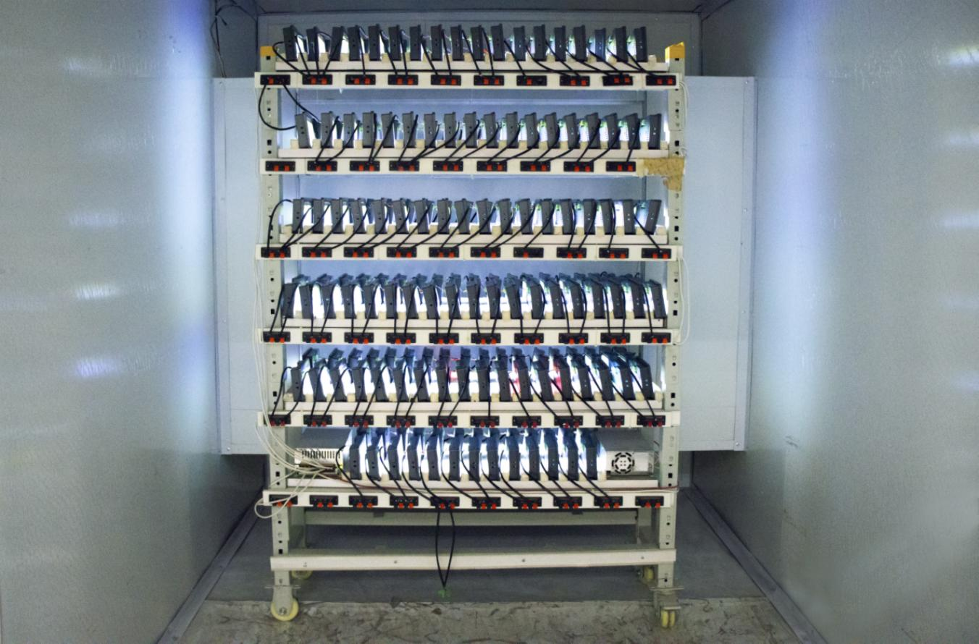
Test Environment: high and low temperature aging test box
Test Temperature: -20° to 70°
Test Process: Place the product in the high and low temperature aging test box. Through 70° high temperature, -20° low temperature, high and low temperature alternating transformation aging test. Observing the product whether resets ,restarts and shows abnormal display, abnormal function, and other phenomena during the test process.
The Test Data
Product model | The temperature | Humidity | The test results
AMZ101P24 | The high temperature of 70 ° | 60% | No reboot, system halt or Abnormal display. Function is normal
AMZ101P24 | Low temperature - 20 ° | 60% | No reboot, system halt or Abnormal display. Function is normal
AMZ101P24 | Alternating high and low temperature (-20°~70°) | 60% | No reboot, system halt or Abnormal display. Function is normal

5.3 Electrical Fast Transient test
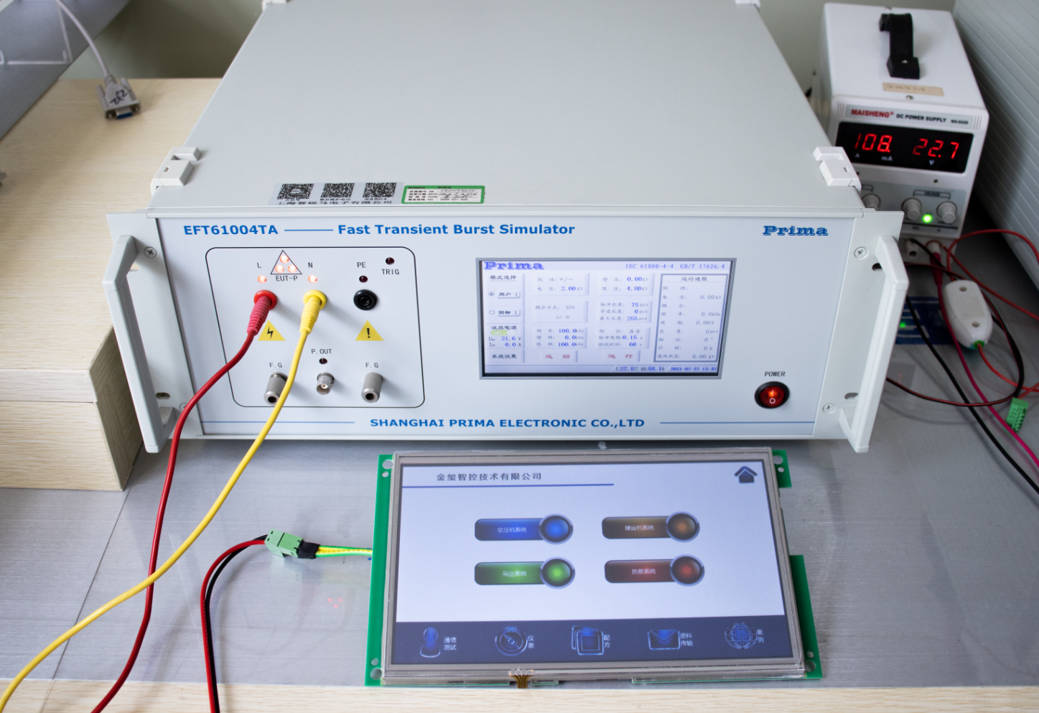
Implementation Standard :IEC 61000-4-4
Test Process: Lay the product flat on the test bench and supply power to the screen through the pulse group generator, coupling pulse group. The diagram above. Check the product whether resets, restarts, and shows abnormal display on the screen.
The Testing Data
Product Models | Test Standard | Test Port | The Test Results
AMZ101P24W01RES | EFT +/-4KV; | The power port | There is no flicker under 1KV , and flicker above 1KV on the screen, but there is no reboot, system halt or abnormal display. Function is normal.
AMZ101P24W01RES | EFT +/-4KV; | Communication port | There is no flicker under 2.5KV , and flicker above 2.5KV on the screen, but there is no reboot, system halt or abnormal display. Function is normal.
AMZ101P24W01RDS | EFT +/-4KV; | The power port | There is no flicker under 1KV , and flicker above 1KV on the screen, but there is no reboot, system halt or abnormal display. Function is normal.
AMZ101P24W01RDS | EFT +/-4KV; | Communication port | There is no flicker under 2.5KV , and flicker above 2.5KV on the screen, but there is no reboot, system halt or abnormal display. Function is normal.
AMZ101P24W01REE | EFT +/-4KV; | The power port | There is no flicker under 1KV , and flicker above 1KV on the screen, but there is no reboot, system halt or abnormal display. Function is normal.
AMZ101P24W01REE | EFT +/-4KV; | Communication port | There is no flicker under 2.5KV , and flicker above 2.5KV on the screen, but there is no reboot, system halt or abnormal display. Function is normal.
AMZ101P24W01RED | EFT +/-4KV; | The power port | There is no flicker under 1KV , and flicker above 1KV on the screen, but there is no reboot, system halt or abnormal display. Function is normal.
AMZ101P24W01RED | EFT +/-4KV; | Communication port | There is no flicker under 2.5KV , and flicker above 2.5KV on the screen, but there is no reboot, system halt or abnormal display. Function is normal.

5.4 Lightning Surge Test
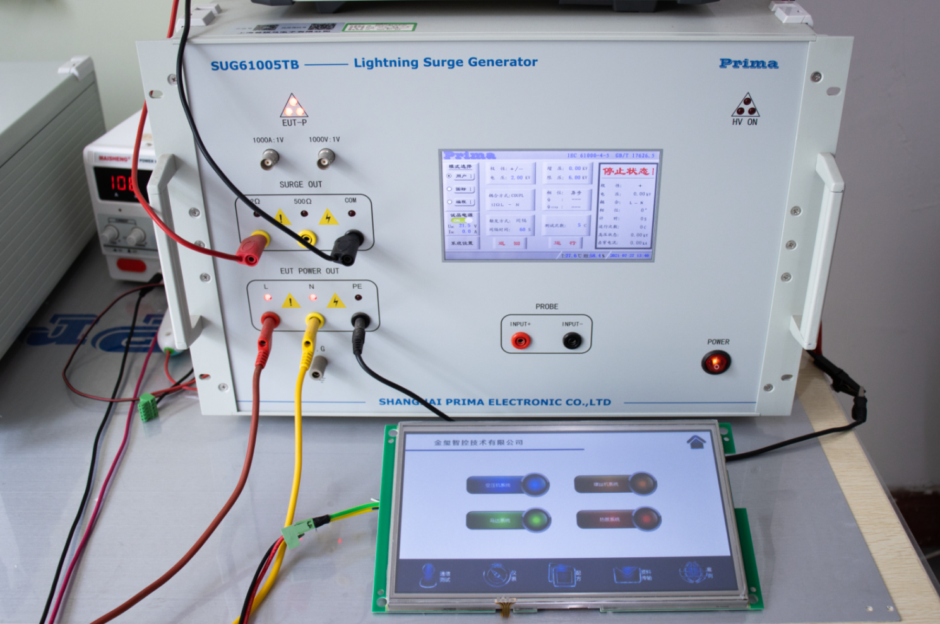
The Test Data
Product Models | Test Standard | Impedance | The Test Results
AMZ101P24W01RES | COUPL | 12Ω | 2KV screen no flickering, 2KV screen has flashing, but no restart, crash, flower screen and other anomalies. Function is OK
AMZ101P24W01RDS | COUPL | 12Ω | 2KV screen no flickering, 2KV screen has flashing, but no restart, crash, flower screen and other anomalies. Function is OK
AMZ101P24W01REE | COUPL | 12Ω | 2KV screen no flickering, 2KV screen has flashing, but no restart, crash, flower screen and other anomalies. Function is OK
AMZ101P24W01RED | COUPL | 12Ω | 2KV screen no flickering, 2KV screen has flashing, but no restart, crash, flower screen and other anomalies. Function is OK

- Software Download

Products configuration software and driver installation method, please go to the official website of Kinseal Intelligent Control company download center to download the following files:《Kinseal_setup_v3.1 configuration software》、《KinsealStudio software installation manual》、《KinsealStudio software driver installation manual》。

Notes: For Windows 7, the system will automatically install the driver after installing KinSealStudio software. For Windows XP and Windows 8, the driver installation fails due to operating system limitations，According to the first《Manual for Disabling digital signatures for Windows 8 and 10》Disabling digital Signatures，then according to the《KinsealStudio software driver installation manual》Manually install the driver.

Software Download Address：http://www.kinseal.com/list-4-1.html

7. Description PC Configuration Software

7.1 Develop software
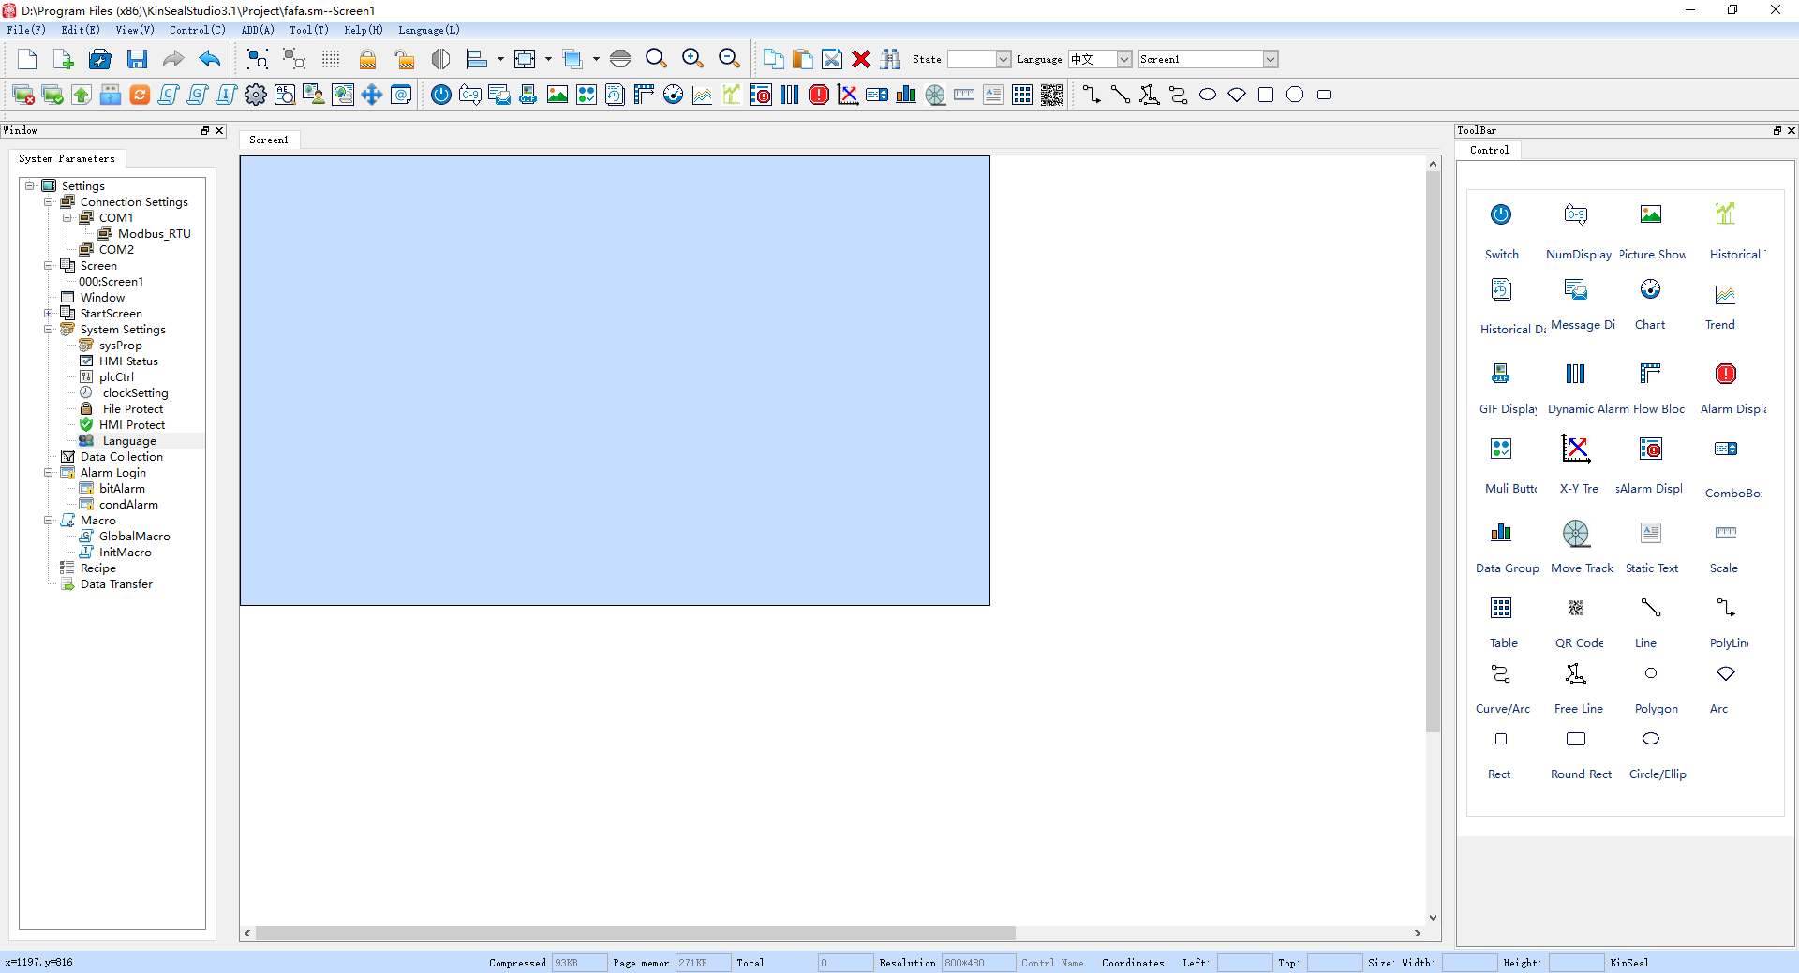

PC Software KinSealStudio is a tool that users can edit arbitrarily. All application programs are developed based on it. KinSealStudio composes rich controls, which can be arbitrarily combined to achieve the functions that users want：

Features Includings：

Switch Button | Including "Bit Button" "Word Button" "Indicator" "Screen Button" "Function Button" "Polymorphic Button" touch the connected device to monitor the status
Numerical Input and Display | Including a variety of base input and display, ASCII code input and display, used to display the monitoring address value;Another time display is used to display the real-time time
Flow Block | An animated graphic that simulates the flow of liquid in a pipe
Static text/table/scale | A variety of basic shapes, including lines, circles, ellipses, rectangles, etc
Image Display and GIF animation | A picture display box that displays one or more pictures
Instrument | Bar chart, meter, ring, showing a value of some state of data
Message Display | Displays messages that be edited by user
Alarm Display | Display the alarm information of the current device (divided into digital alarm and analog alarm), Alarm settings must be configured before using the control
Dynamic Alarm | Used to display the current alarm, which is different from the alarm control is the dynamic alarm bar in the form of text scrolling display the current alarm content
X Y Curve | Real time and dynamic display of data trend of data collector
History Curve | Displays the data saved by the history collector in curvilinear form
Recipe | Create a recipe like menu
Multifunction Button | A switch button, through the button can be very convenient to achieve a variety of functional requirements
Trend Chart | Draw reference curves of multiple data to accurately and intuitively judge the change trend of a certain value in a period of time
Dropdownlist | Used to select the corresponding state function
Data group | To display the data change from register address N to register address N as a curve
Motion trail | Control address data by dragging a scroll block
Qr code | Dynamic generation of QR code, through scanning into the url, payment and other functions

Extended Function Of Host Configuration Software：

Macro Instruction | C programming language, to achieve a variety of more complex logic or functions
PLC Control | HMI is controlled by PLC
Language | Support for multiple languages
Data Collection | Data acquisition for temperature, pressure, humidity, etc
Data Transmission | Refers to the transmission of data over the same type of address. The transmission mode can be periodic (how many seconds) or triggered
HMI Protection | It is set that HMI can normally use HMI within a certain period of time. If the time exceeds the time specified by the user, HMI will jump to the specified screen previously set by the user. In the specified screen, the user only places the "Panel protection unlock button" under the function button.
File Protection | Whether to enter a password when opening the project
User password Level | Set the user permission and password. Enter the password to access the corresponding permission
Boot Screen | Users can customize the startup Logo screen
Online Simulation | Online simulation enables you to communicate with relevant devices such as PLC through personal computer (HMI configuration software needs to be installed first) without HMI
Offline Simulation | Before the picture is compiled and downloaded to the HMI device, the offline simulation function of HMIStudio can be used to check the correctness of the configuration picture and the effect display
Supports Multiple Controller Communication Protocols | Suitable for a variety of PLC, inverter, servo controller, SCM control system (Mitsubishi, Panasonic, Omron, Delta, Letter Jie, Fatek, Siemens, Keens, LG, and other major PLC) user operation only need to choose to call directly on the software
Custom Add Gallery | Support custom add gallery, users can according to the need to intercept their favorite picture loaded into the custom gallery to call
Keyboard | Support Chinese and English keyboard input, users can freely switch to use
Gallery | Image library rich, support Png, Jpg, Gif, Bmp and other formats of pictures, vector image library, arbitrary zoom without aliasing
Baud Rate Range | Support serial baud rate range of 1200-230400

7.2 Protocol Configuration
Users can run MODBUS RTU, Mitsubishi, Siemens, Delta,Xinje and other protocols through the configuration of the upper computer.
Open KinSealStudio configuration software and click on new project to select the desired communication protocol in new project. You can also modify the communicate on protocol you need in the project by opening the protocol under COM1 port Settings. The diagram below.

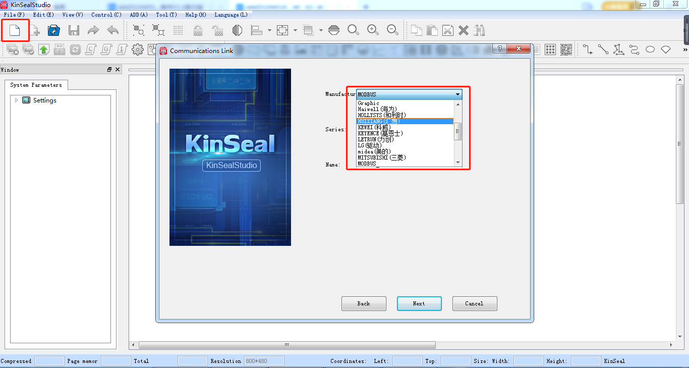
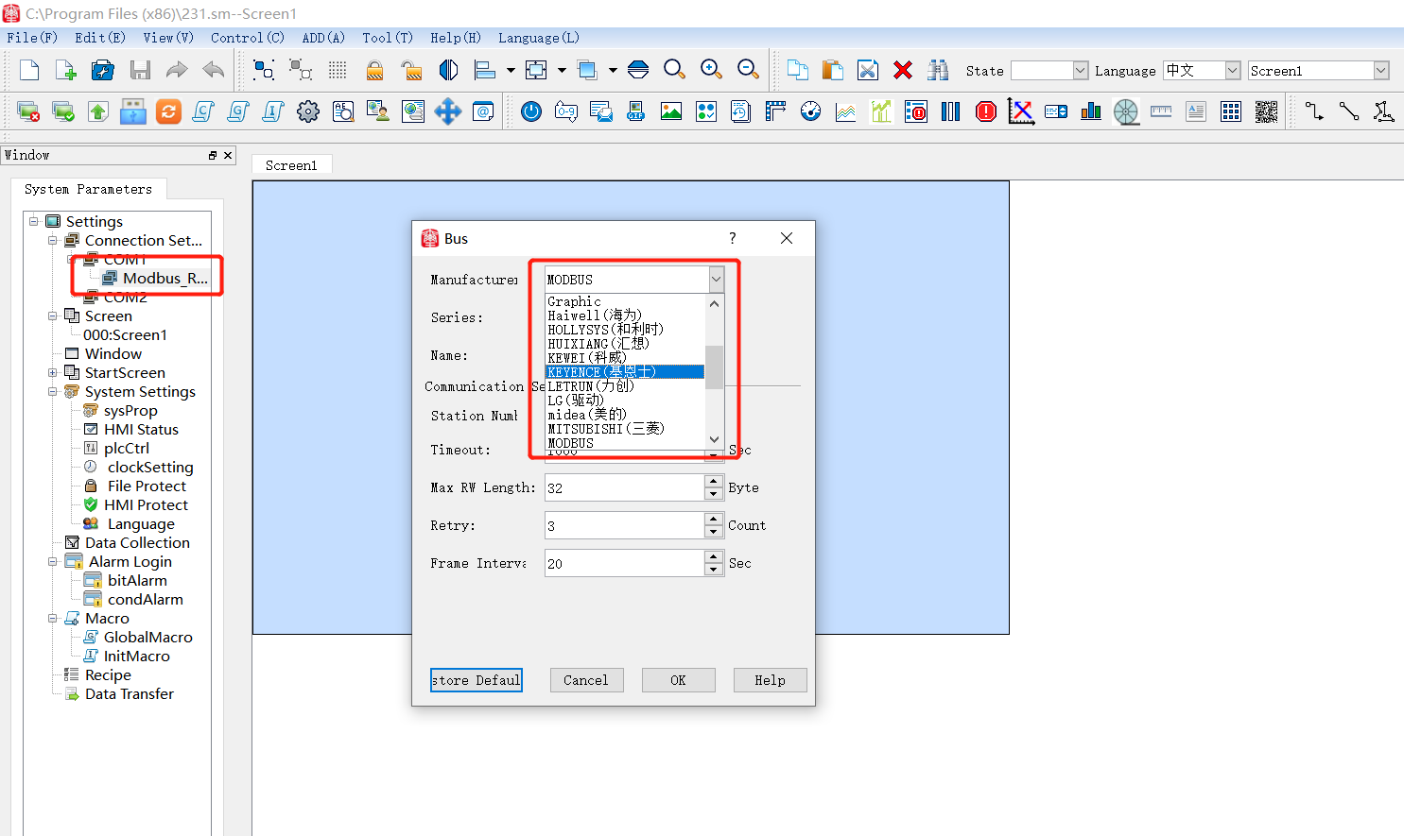

8. Development Of The Document

In order to complete the products development more faster, beginners can log in the official website http://www.kinseal.com，enter the "Download center" bar, download the corresponding "communication case", "project case", "video tutorial" and other technical documents. For more technical knowledge, please call: 086-13641442131 or e-mail kinseal@kinseal.com



Committed To Creating The Best
Intelligent Control Terminal

